1. Configure VPC peering in cross regions.

MUMBAI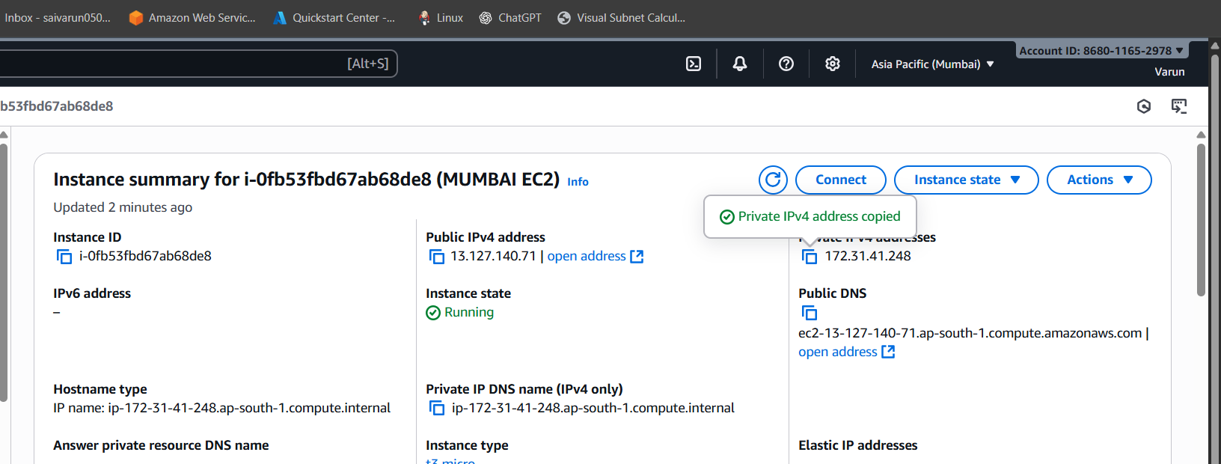

CANADA

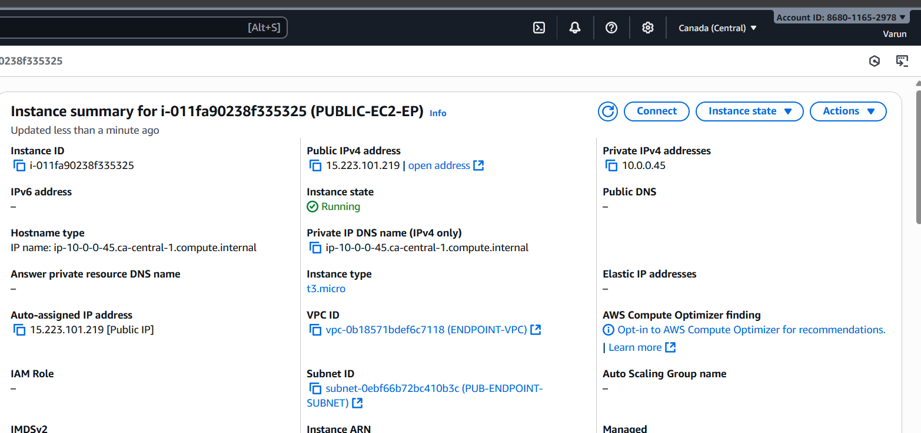

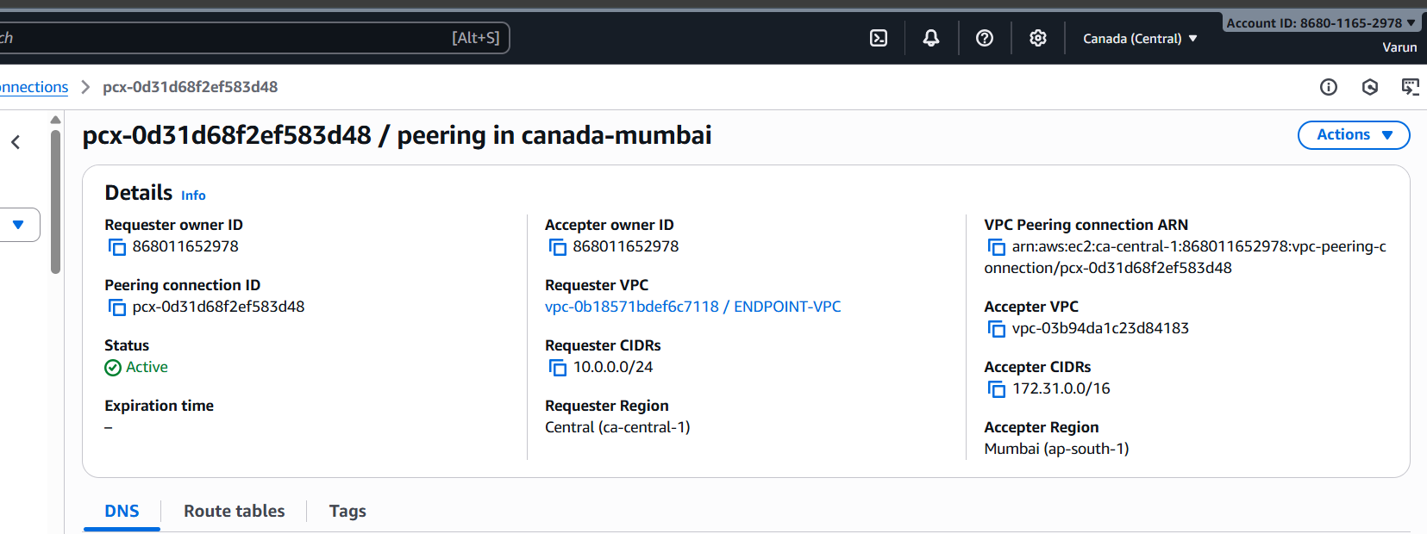

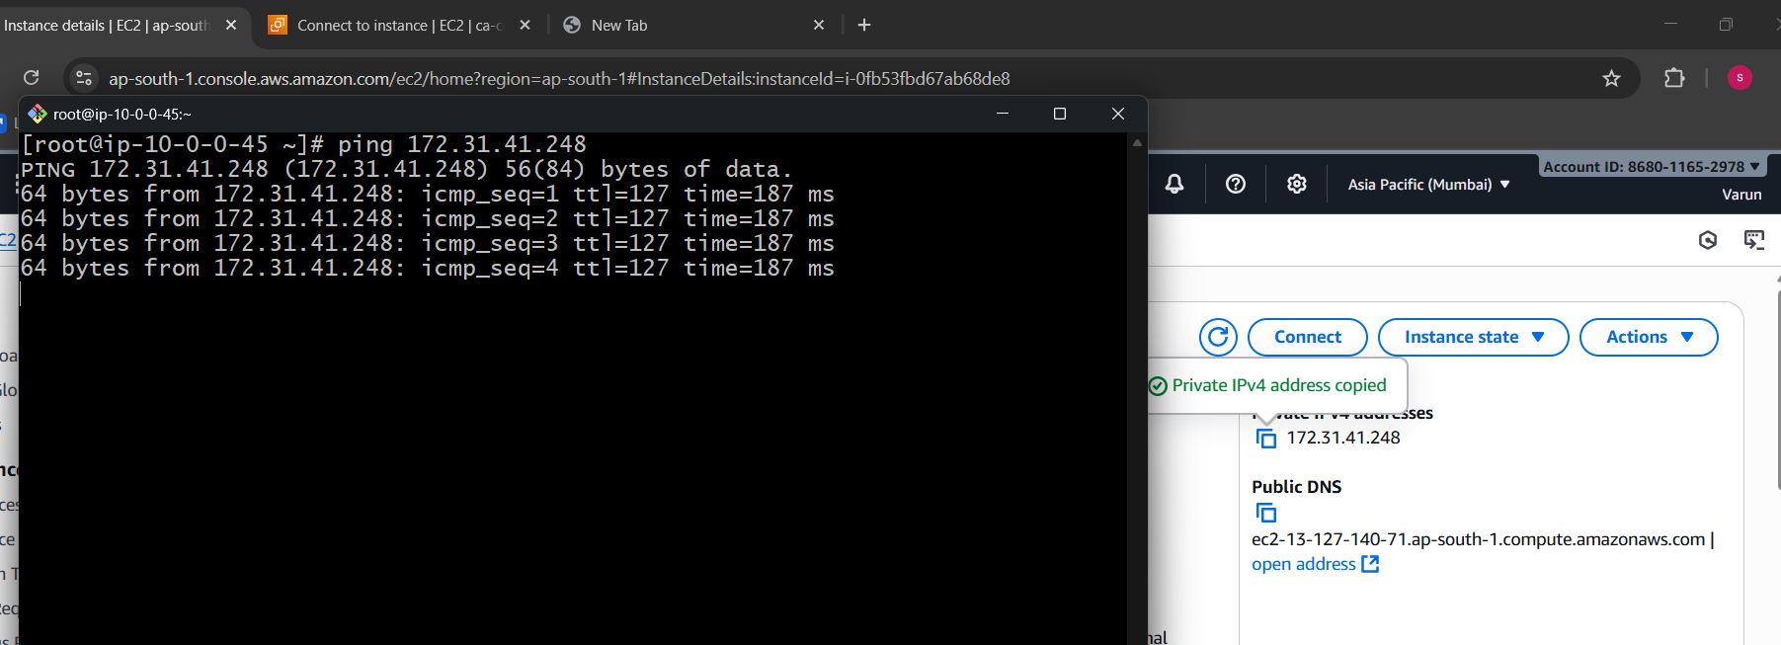

* Create 1 ec2 in Mumbai with vpc connected to it and it should be public.
* Create 1 ec2 in Canada with vpc connected to it and it should be public too.
* Now try to connect Canada instance with Mumbai’s by creating a peering request and accept it from the othjer end user.
* Once the connection is established configure the same in route tables by giving the vpc ids and peering connection ids in each other.
* Now try to connect to instance in Canada and ping to mumbai’s private ip address.
* We can see the connection establishment between this two regions.

1. Purchase one domain from GoDaddy.

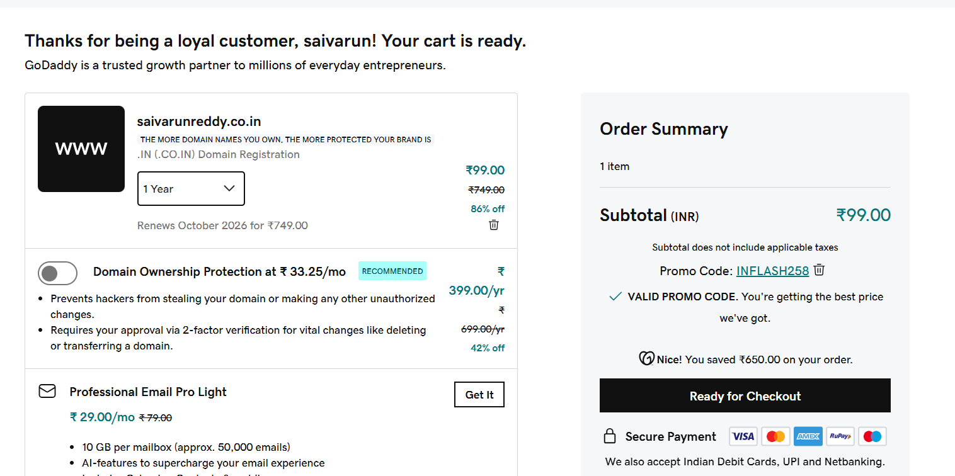

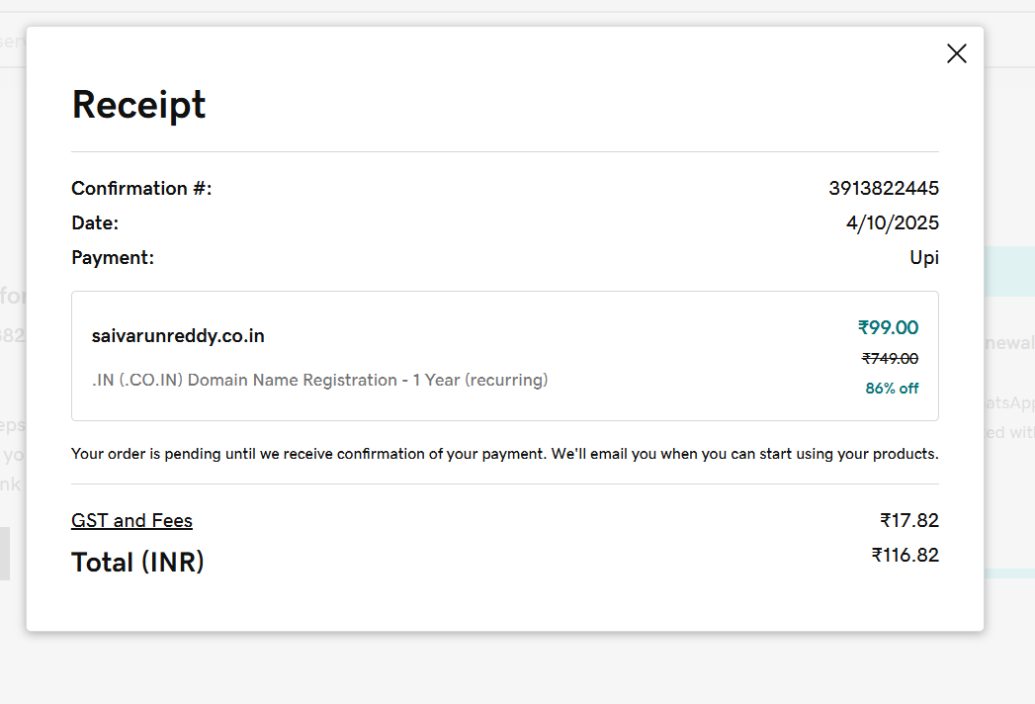

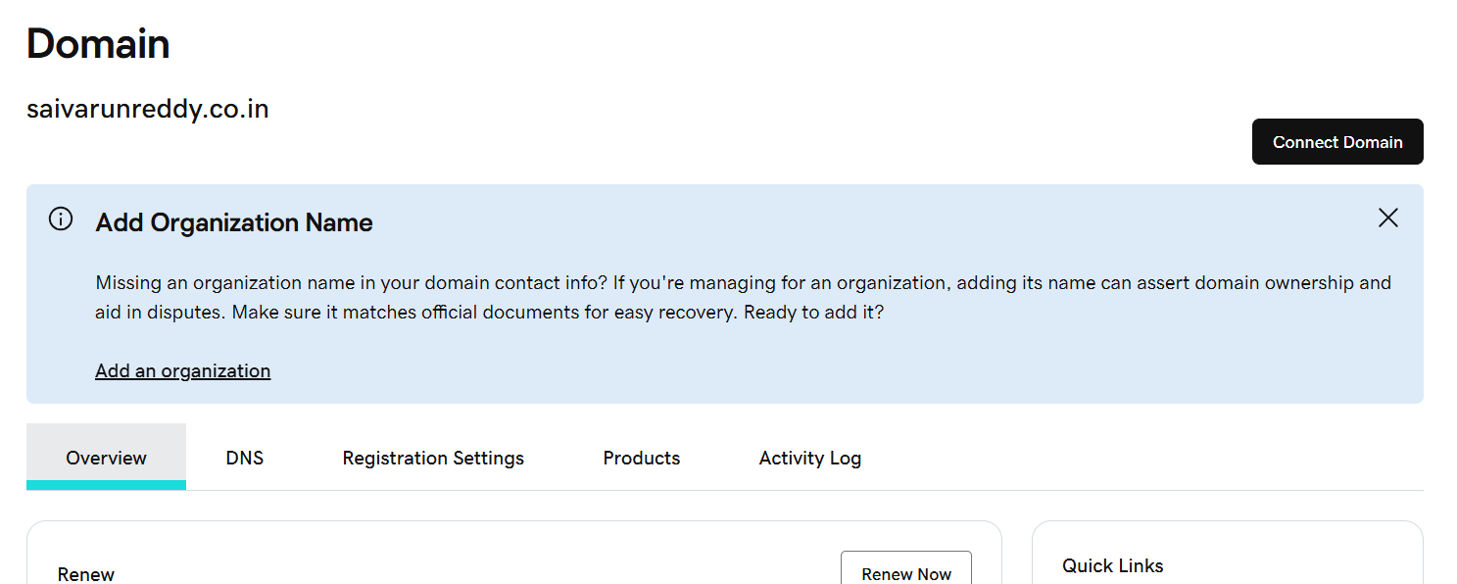

1. Deploy static website in S3.

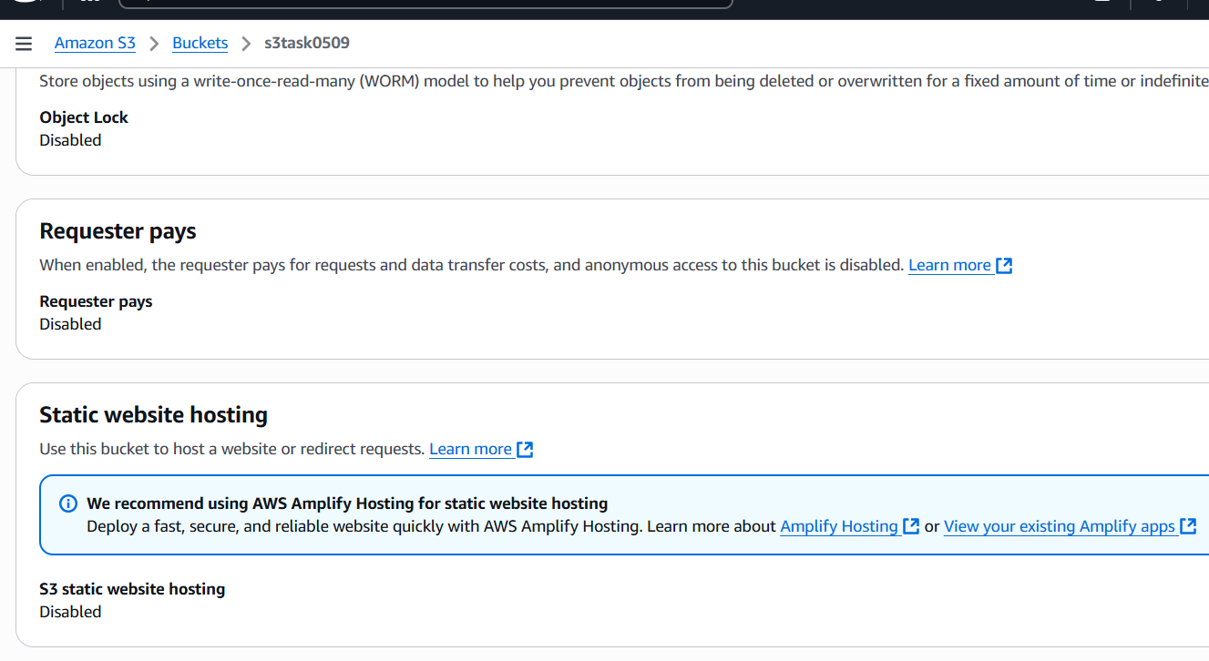

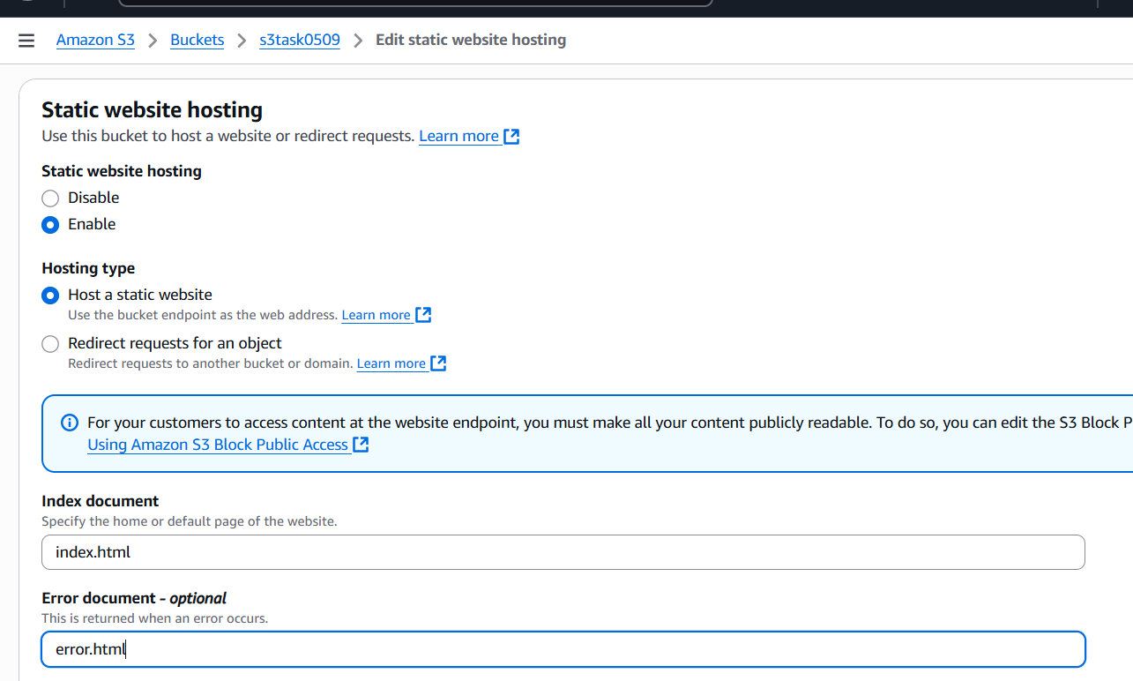

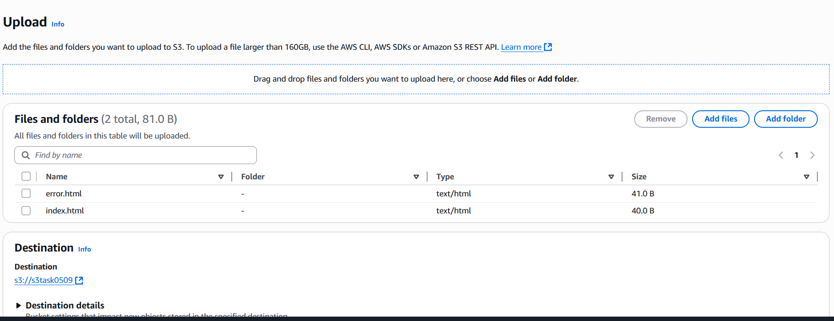

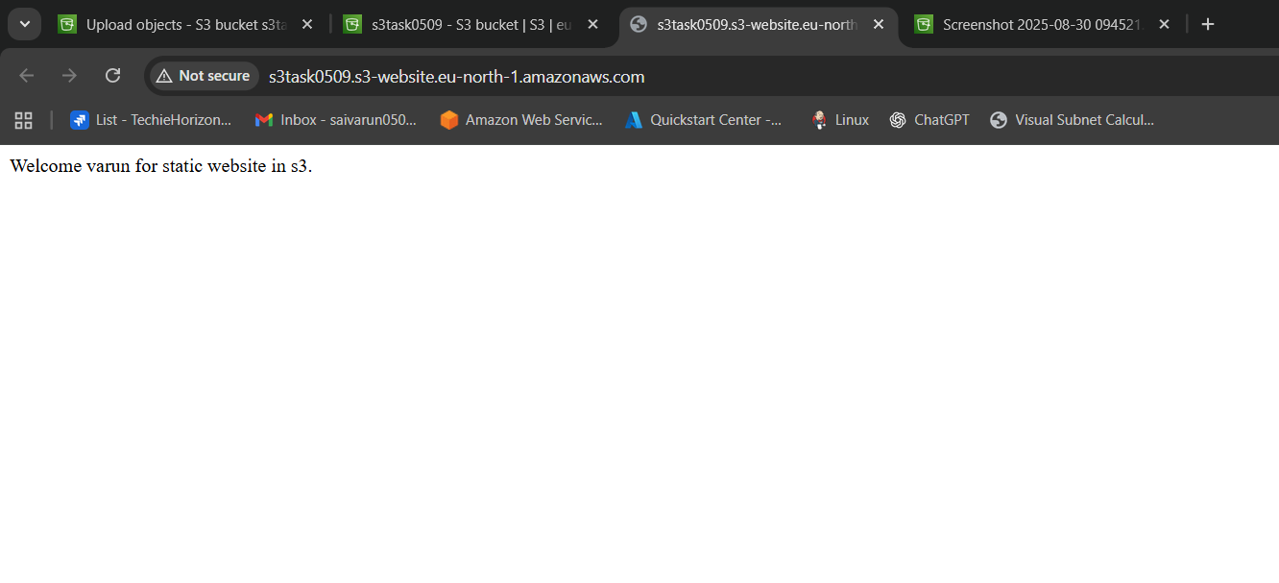

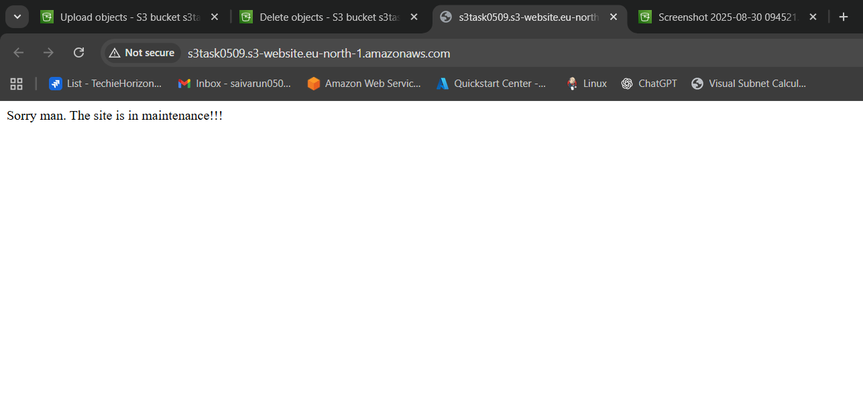

* Go to the s3 bucket.
* Properties-enable static website hosting.
* Give the files names index.html and error.html.
* Then save the website hosting.
* Upload the index.html and error.html files to the bucket make it public access.
* Copy the link generated and paste it in the browser to check.

1. Create a CDN and attach one SSL certificate.

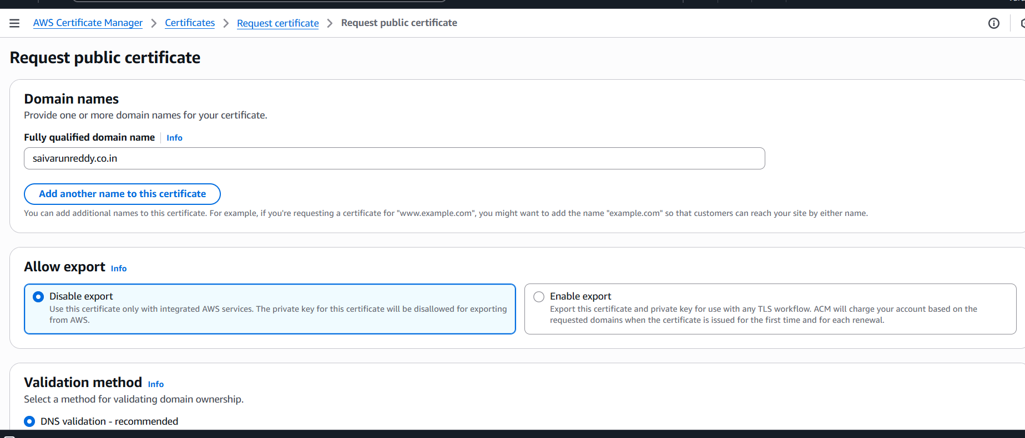

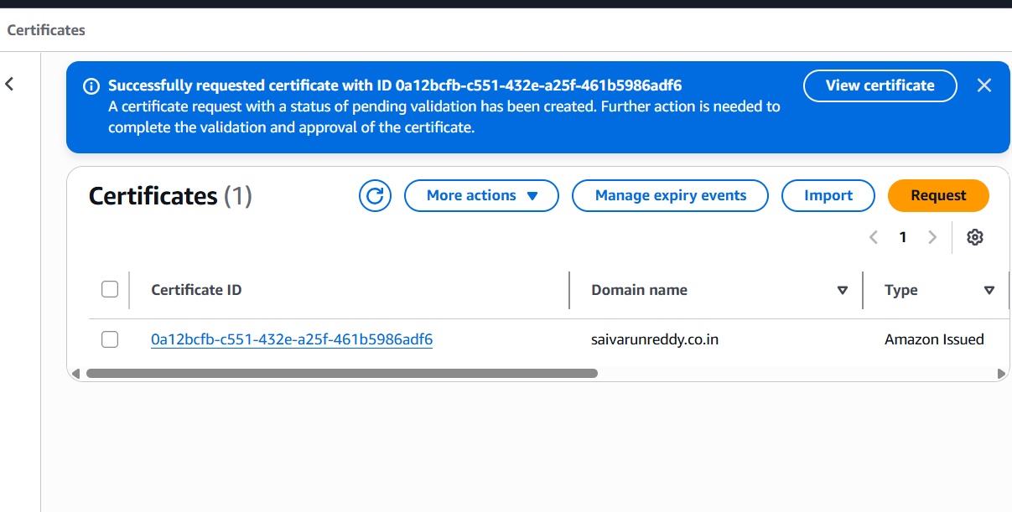

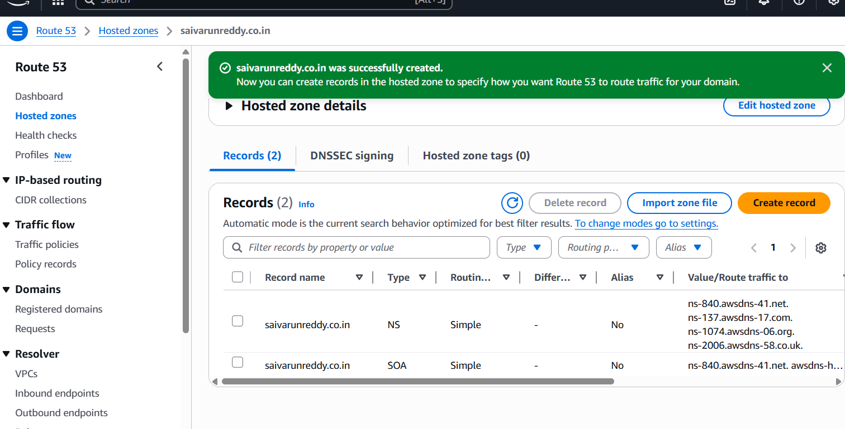

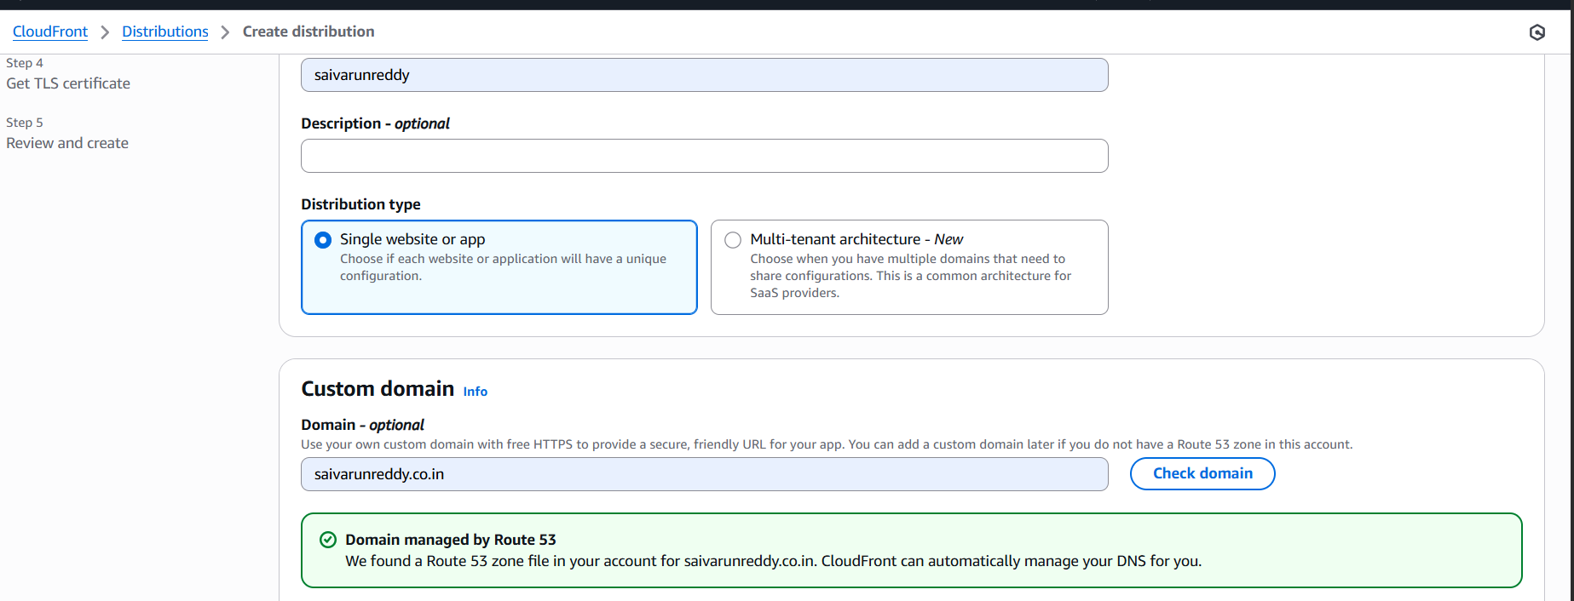

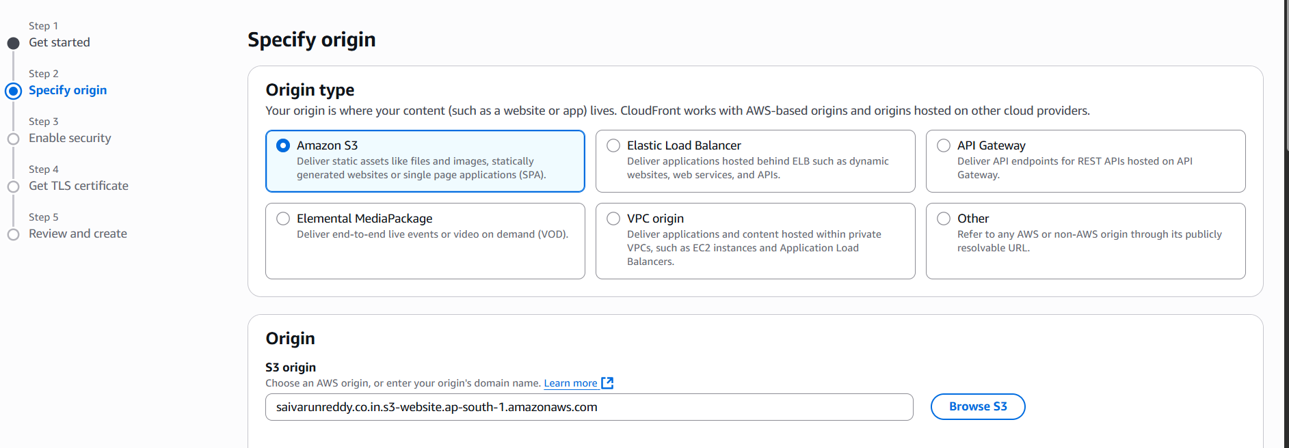

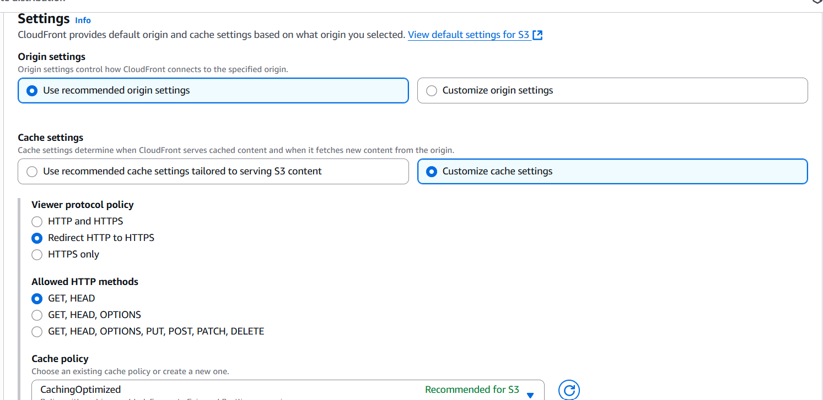

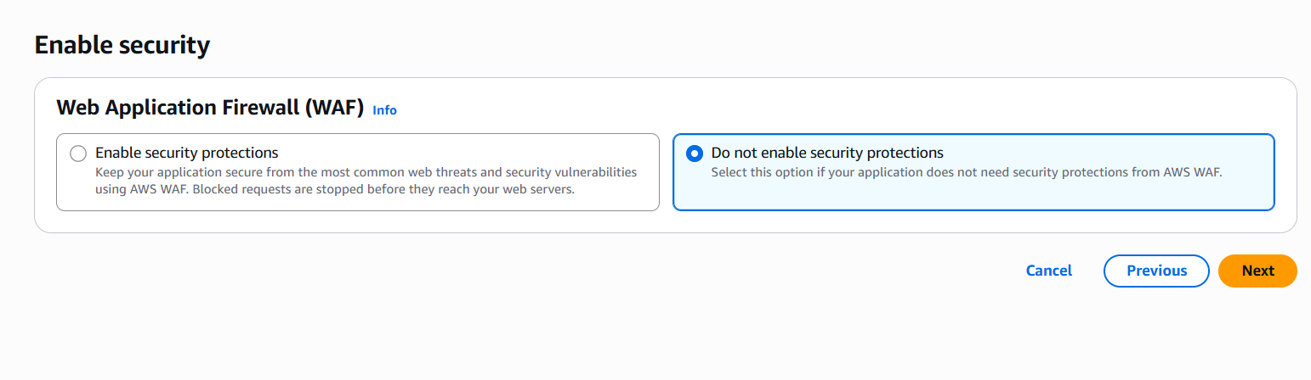

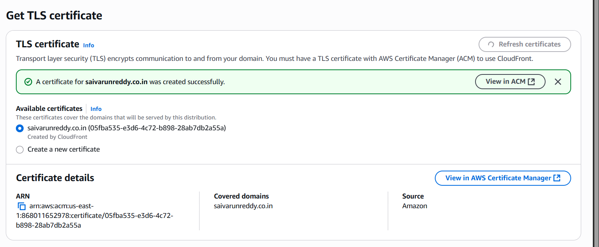

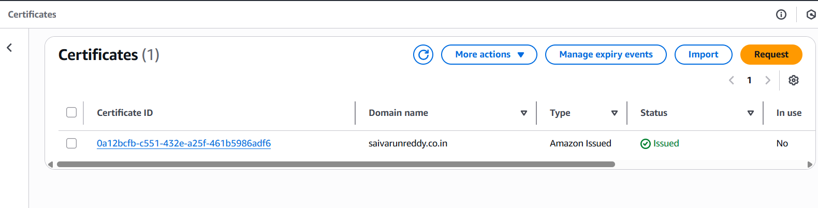

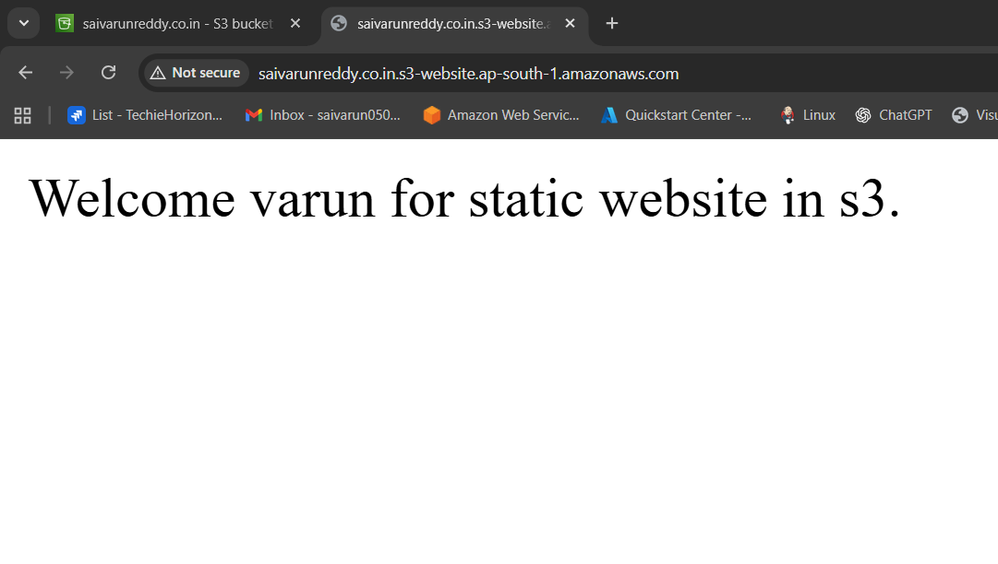

1. Create a Route 53 hosted zone and map the domain with the CDN.

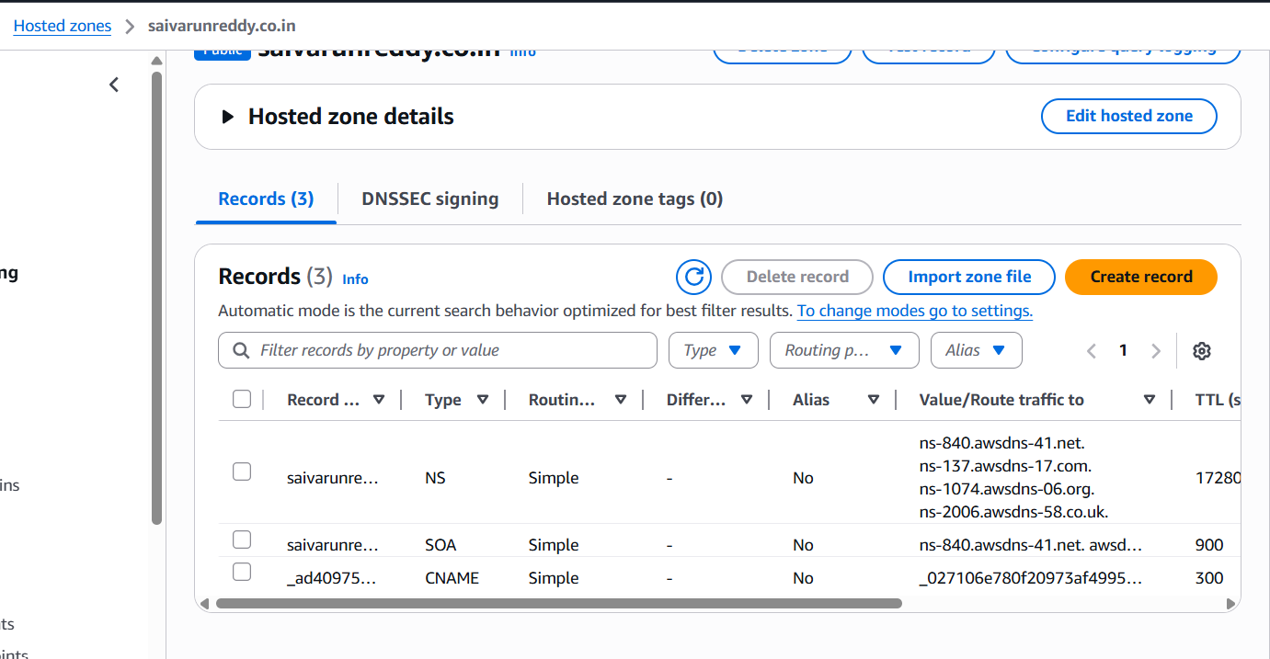

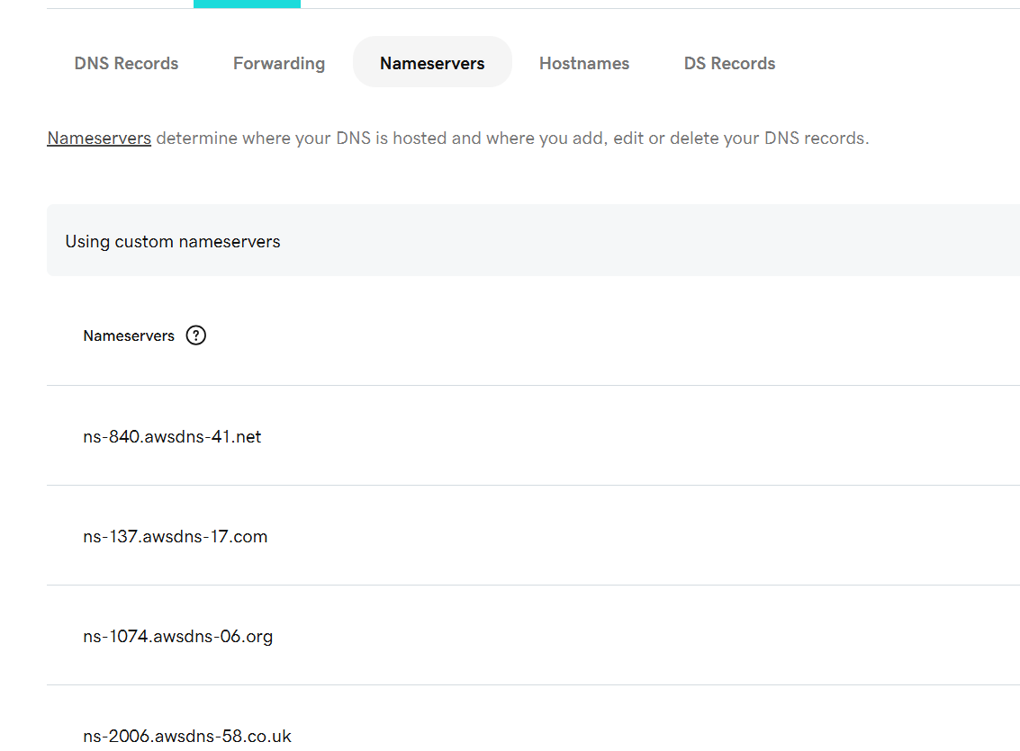

•Go to root 53 in aws console

•Create records to the

•The four websites will be generated go to go daddy.com

•Your domain – name servers -copy the four dns names and add it in the

server names in the go daddy

1. Update the index.html in the S3 bucket and ensure the updated file is accessible using the domain name.

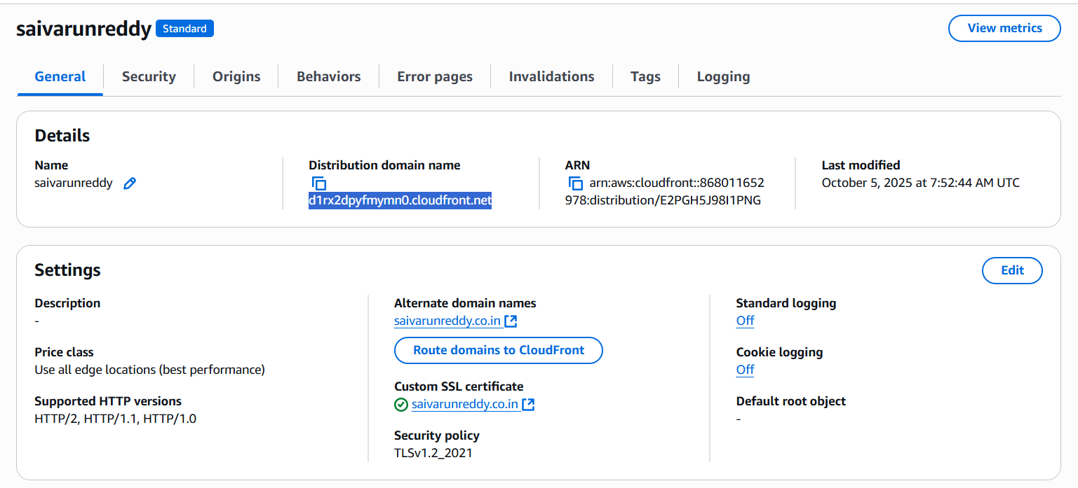

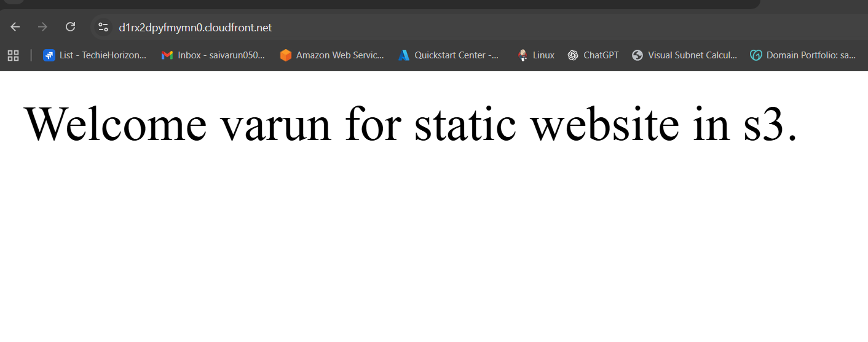

•Go to the cloud front distribution.  
•And copy the distribution domain name.  
•And paste it in the browser.

1. **Share the domain name in Slack to test the connectivity.**

saivarunreddy.co.in

